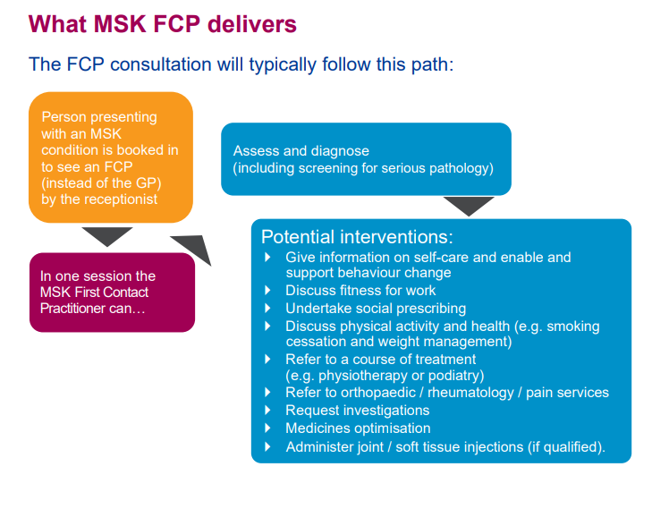

By a combination of telephone and face to face consultations. Telephone consults to be 20 minutes long, face to face 30 minutes.

The FCP needs the ability to modify their appointments to meet the needs of their patients.

Our first FCP joined us in January 2021 and will be undertaking the First Contact Practitioners and Advanced Practitioners in Primary Care: (Musculoskeletal) A Roadmap to Practice. They are qualified practitioners and will be able to start seeing patients but like other ARRS staff will have job specific training.

The first stage is actually being in practice and the modules will be done whilst in post. Like the CP’s they will be given time out for training and need to be mentored. There is funding for this and the SWGPF will liaise with us like other ARRS roles.

How the service will be delivered